Activity part 1 will be to install openvas via gvm in Kali Linux: Document each process with a screenshot:
- Run your Kali Linux
- Open up a terminal
- You must be in root on your terminal: run command
sudo su; enter password for Kali
- sudo apt install gvm
- check installation of gvm:

run command: gvm-check-setup -h

- Then run:
sudo greenbone-feed-sync This will take a while …..Do not close your kali until you finalized your installation.

- During installation, you will be required to input a username and password for admin, take note of the username and password. Just in case you forgot about it later: you need to type this command:
sudo runuser -u _gvm –- gvmd --user=admin --new-password=new password (password of your choice)

Part 2, once gvm has been installed. Do the following: (include screenshots)
- Run command Line (make sure in root of Kali)
- Use command gvm-start -h
- Browser will open once gvm has started properly. Use admin username and password credentials. Your screen may look like this if feed was sync successfully:

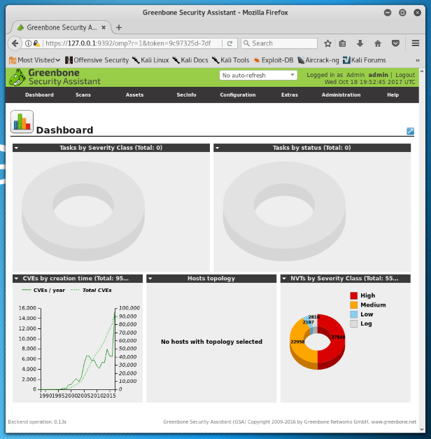

- Choose from the navigation Scan -> Task -> Look for the Magic Wand similar to the image below and choose Advanced Task Wizard.
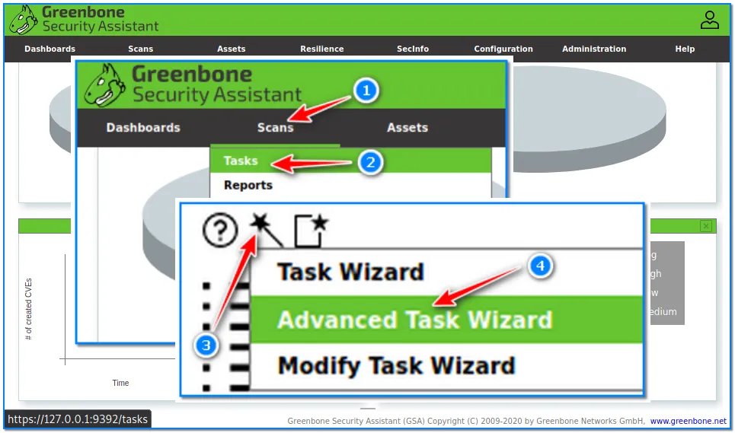
- In command line, run ifconfig and look for your ip address either LAN or Wifi-Lan
- Follow the image below:

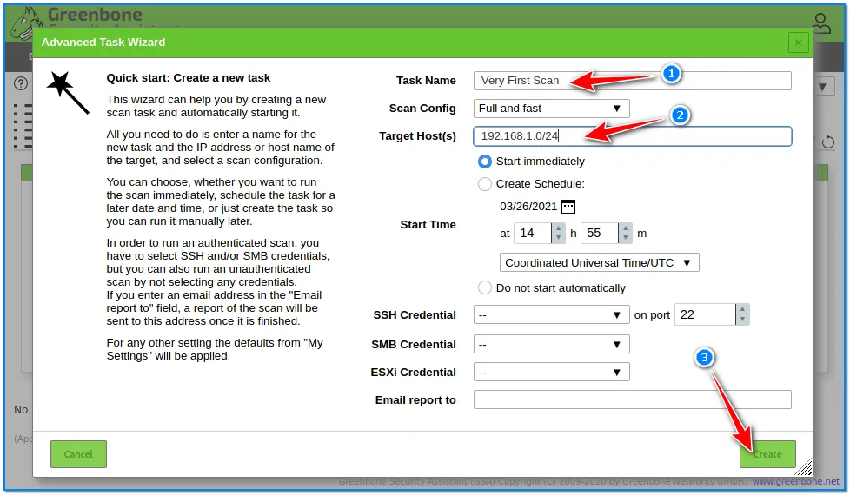
Change the ip address using your ip address and set the time and date for the scan plus leave the port as is. The click create.
- Once scan is completed, you need to show results, reports, and vulnerability similar to this image:
